**Chapter 3**

**Information Gathering**

**3.1 Introduction**

Information gathering is an art and a science. The approach and manner in which information is gathered require persons with sensitivity, common sense and a knowledge of what and when together and what channels to use in securing information. Additionally, the methodology and tools for information gathering require training and experience that the analyst is expected to have. This means that information gathering is neither easy nor routine. Much preparation, experience and training are required. To gather information from the organization different kinds of tools are used. The analyst must decide on the information gathering tool and how it must be used. Although there are no standard rules for specifying their use, an important rule is that information must be acquired accurately, methodically, under the right conditions and with minimum interruption to user personnel. So, it is necessary to be familiar with various information gathering tools. Each tool has a special function, depending on the information needed.As we are going to make an analysis on the prevailing system,so we have gathered the required information from different sections of the organization using some tools.

**3.2 Information gathering using different tools**

In this section we have presented the information we have collected from the respective organization.

**Services From BTCL:**

**[Telephone](http://www.btcl.gov.bd/services/telephone)**

Enjoy Telephone and high-speed Internet (ADSL / GPON) connection simultaneously

**[Internet](http://www.btcl.gov.bd/services/lli)**

Stay connected to the world through Leased Line Internet and VPN

**[Domain & Hosting](http://www.btcl.gov.bd/services/domain)**

Get your country web-address on the Internet using the .bd/.বাংলা domain

**[Transmission](http://www.btcl.gov.bd/services/transmission)**

Enjoy service with Nation-Wide optical fiber connectivity and Co-Location facility.

**[Bill and Payment](http://www.btcl.gov.bd/pages/2/telephone-bill)**

BTCL offers to print and pay your bill online.

**[Complain Online](http://www.telesheba.gov.bd/)**

Customers place their complain online and track their ticket.

**BTCL Telesheba**

It is a public service oriented application. It enables the subscribers of Bangladesh Telecommunications Company Limited (BTCL) to complain the services(Telephone, Internet-GPON, ADSL, Bill etc.) provided by BTCL. The complaints submitted by the subscribers will automatically notify the respective officers of BTCL so that they (BTCL Officers) can fix the complaints and notify the subscribers also. BTCL subscribers can get the complaints status through this application and give their feedback. Important features are:

* Telephone, Internet and Bill related Complaint
* Bill Query and Payment
* Notifications for any actions on complaint
* Customer Opinion/ Feedback

**Resources:**

* HR(manpower)
* Equipment
* Land Offices
* Fund/capitals
* Others
* OFC

**Services:**

1. Licenses
2. Public :

2.1Telephone

2.2 Internet

LLI

VPN

ADSL

GPON

2.3 Colocation

2.4 Backhaul Fiber

**3.3 Interview**

**1. Interviewer:** How do you think this organization play role to provide quality service?

**Interviewee:**  We provide services of Telephone, Internet and Bill related Complaint, Bill Query and Payment Notifications for any actions on complaint, Customer Opinion/ Feedback.

**2. Interviewer:** Do you think you have enough manpower?

**Interviewee:** No. Till now we are facing some problems in tasks like digitalization of our

data need more skilled manpower.

**3. Interviewer:** What are the services provided by BTCL?

**Interviewee:** Licenses, Telephone, Internet, Colocation, Backhaul Fiber.

**4. Interviewer:** What are the internet services provided by BTCL?

**Interviewee:** LLI (Leveled Literacy Intervention), VPN (Virtual Private Network), ADSL (Asymmetric Digital Subscriber Line), GPON (Gigabit Passive Optical Network).

**5. Interviewer:**  What are your new services?

**Interviewee:**  GPON, ALAAP.

**6**. **Interviewer:**  How your organization have been digitalized in sectors?

**Interviewee**: In billing, application, payment, payroll, online complain management (telesheba), server side, meeting management.

**7**. **Interviewer:** What kind of cables are being used for transfer of data provided by BTCL?

**Interviewee:** We have been providing customers with copper wires since from time immemorial but now those are getting replaced by optical fibers.

**3.4 Equipments in Factory(Malopara Branch):**

**DWDM-01**

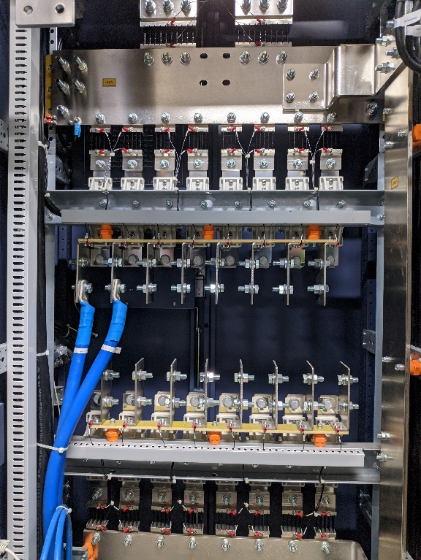

**Connections for distribution:**

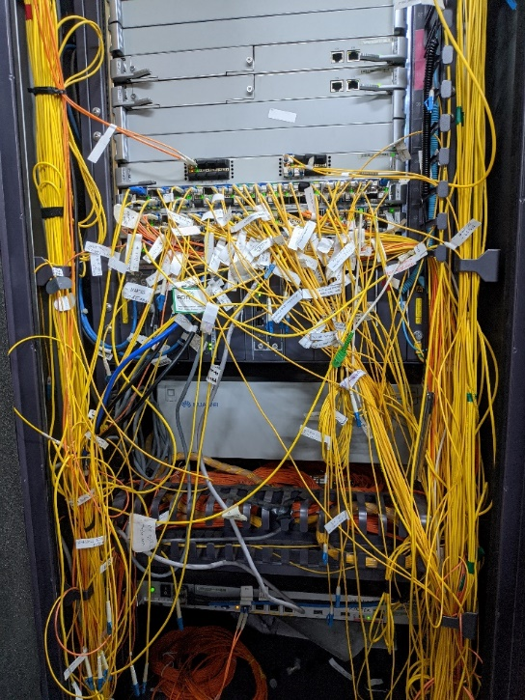

**IP List of Rajshahi Area:**

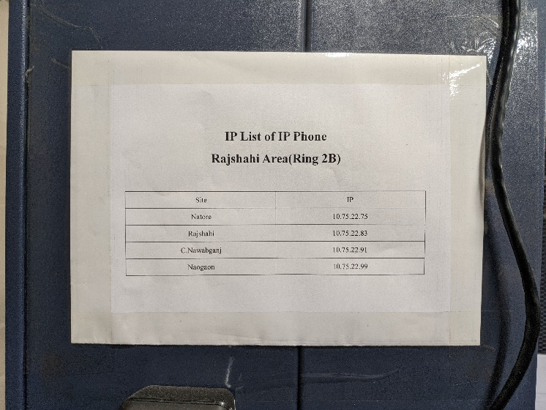

**Diagram for Distribution in Rajshahi Area:**

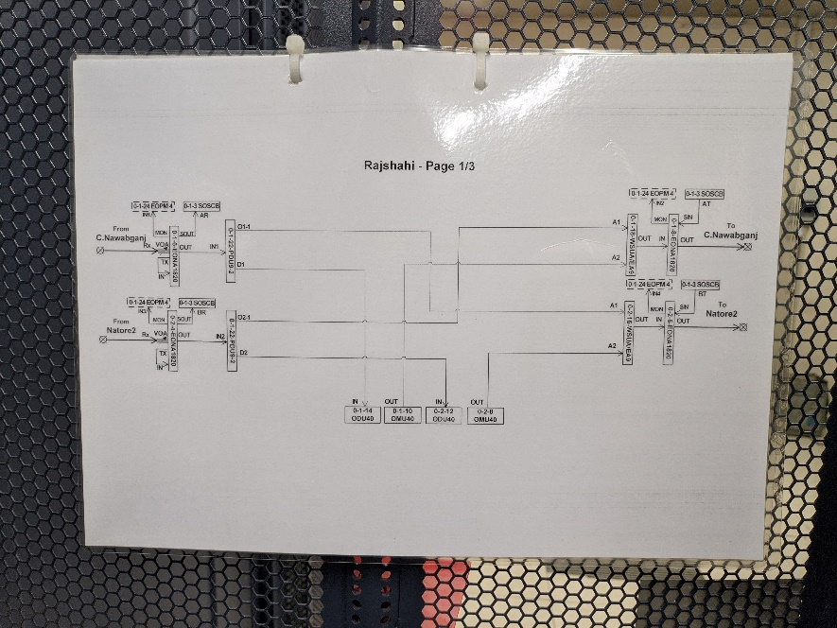

**Fiber Routing Diagram and Connection:**

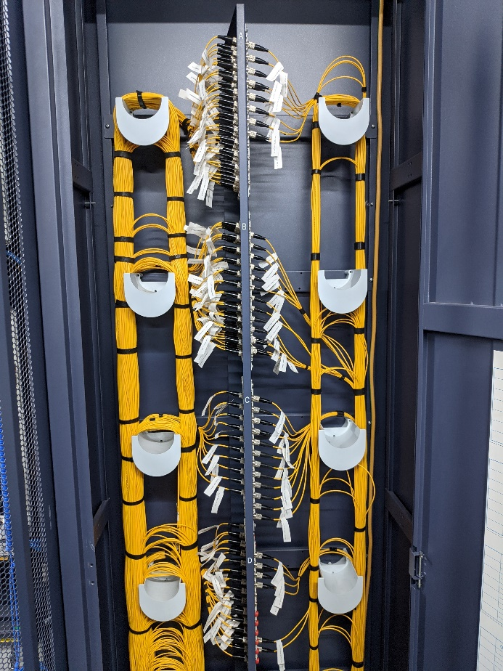

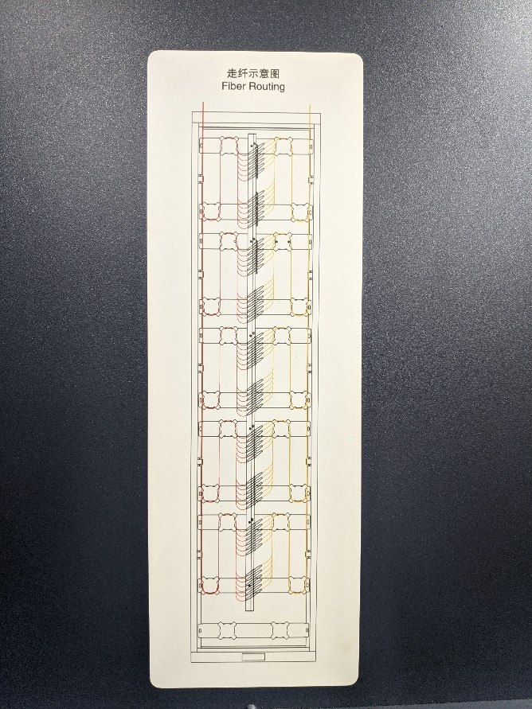

**DDF:**

